FSWD80-Database-DAY01-Chris-Dennis-Sarah

Documentation:

Exercise 1:

- Step 1: Define Purpose
detailed information about book collection

- Step 2: ER diagram
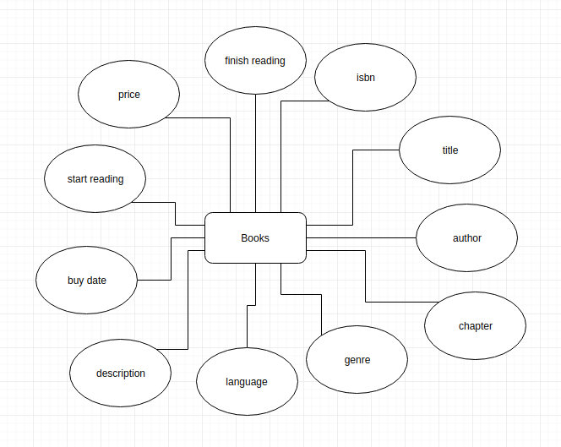
- Step 3 and 4:
